MySQL Tasks

1. What is the difference between DBMS vs RDBMS.

DBMS

IN DBMS data is stored in files.

Normalization is not possible.  
  
  
No security.

Single file based.  
  
Ex: txt,json,xml files

RDBMS

IN RDBMS data is stored inform of tables which can be related.

Normalization is present   
 in RDBMS.  
   
 ACID(Atomocity,Consistency,  
 Isolation,Durability)  
  
 Supports distributed system.  
  
 Mysql, oracle, sql server

1. List the different databases used  
   Microsoft Access  
   Microsoft Excel  
   Microsoft SQL Server  
   MySQL  
   Oracle RDBMS  
   Quick Base  
   Hadoop  
   BigData
2. Define a database, table & column  
   a database consists of one or more tables. Each table is made up of rows and columns.  
   Column is vertically grouped cells in table within db.  
   Rows are the entry which may consist of same or different type of data within table inside db.
3. Write the syntax to create a database and to select the database

CREATE database *sample;*USE *sample;*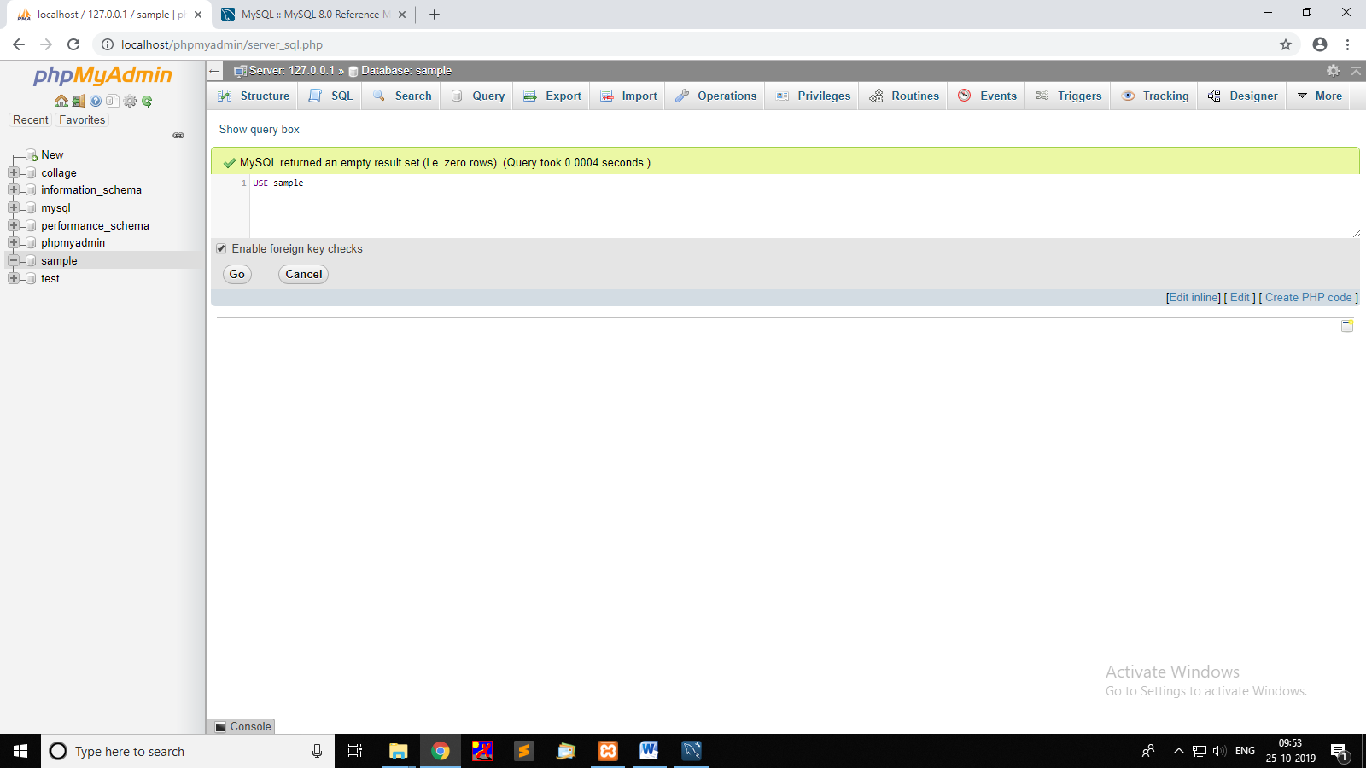

1. Write the syntax to create a table  
   CREATE TABLE *my_ta(id int,name text);*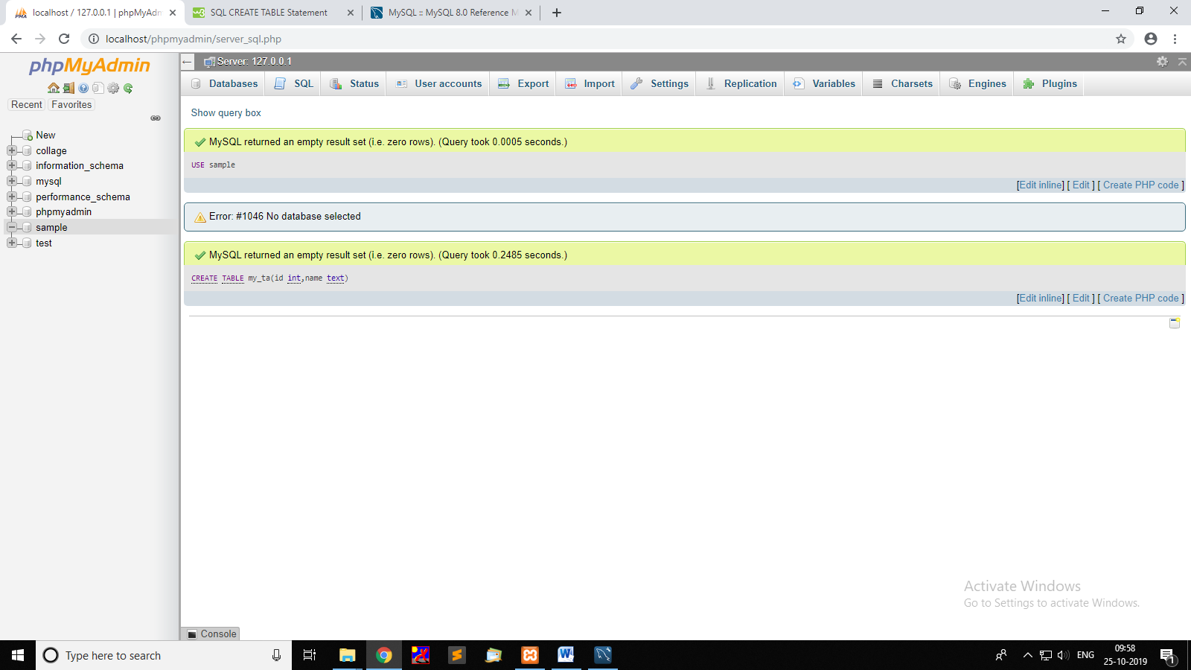
2. List the DDL & DML statements

* DDl: Data Definition Language
  1. Create: It is used to create the database or its objects  
      like table, index, function, views, store   
      procedure and triggers.
  2. Alter: Used to alter the structure of the database.
  3. Drop: to delete objects from the database.
  4. Truncate: Remove all records from a table.
  5. Rename: rename an object
* DML: Data Manipulation Language
  1. Insert: to insert data into a table.
  2. Update: update existing data
  3. Delete: delete records from a database table.

1. List the difference between Delete & Truncate

Truncate  
  
can't Rollback after performing Truncate  
  
locks the entire table.  
  
Can’t use WHERE  
  
Trigger is not fired while truncate

Delete

We can Rollback after delete.  
  
Locks the table row.  
  
Can use WHERE to filter data to delete  
  
Trigger is fired.

1. Write the syntax of Insert, Delete & Select  
   Select * from *my_ta;*Insert INTO *my_ta* VALUES (*‘111’,’Ayush’);*DELETE FROM my_ta;  
   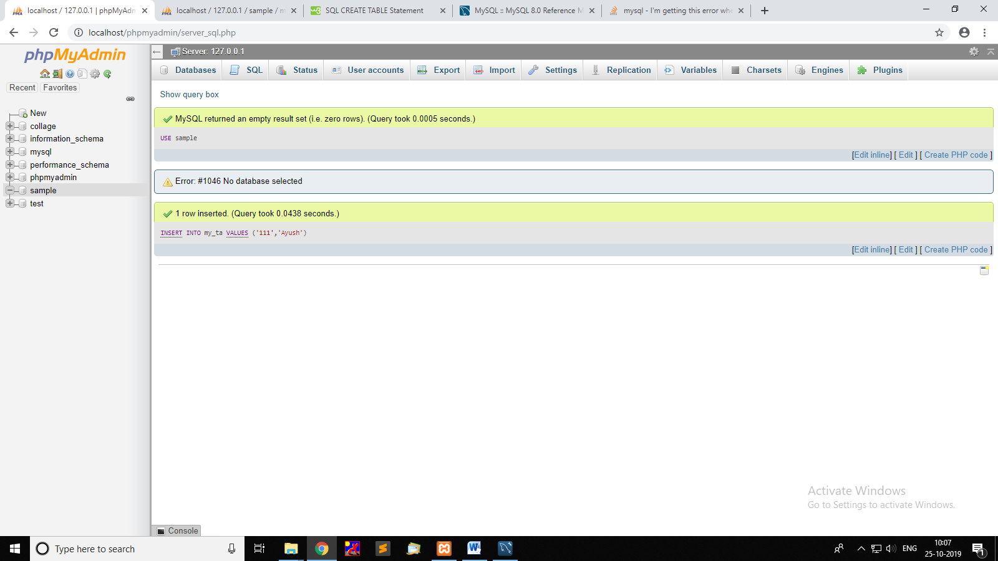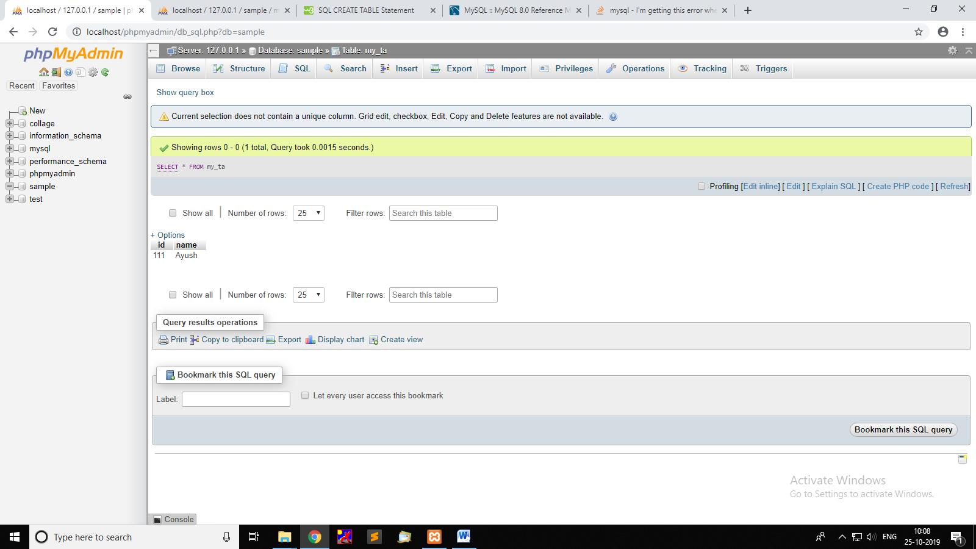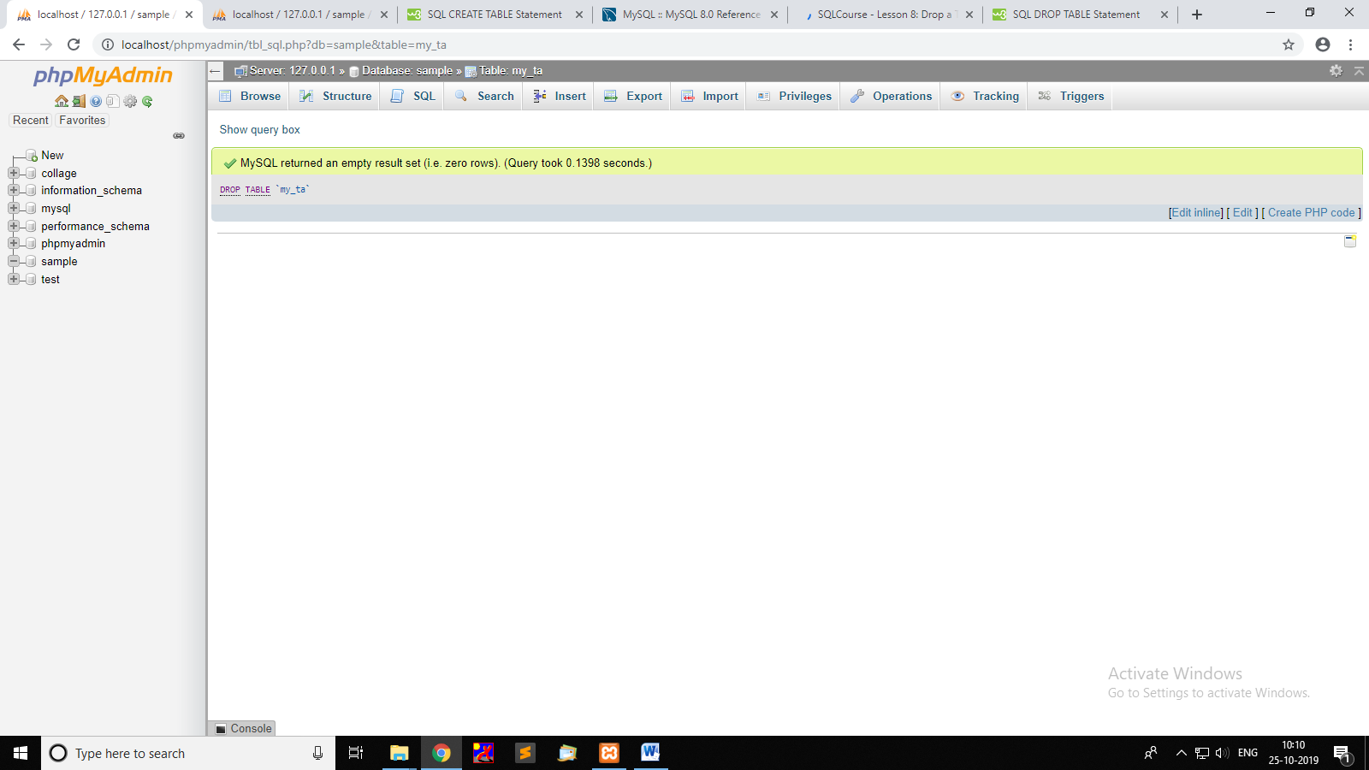
2. Write a query to insert 3 rows in a table  
   Insert INTO *my_ta* VALUES   
   (*‘1’,’ayush’),*(‘2’,’jai’*),*(*‘3’,’sharad’);*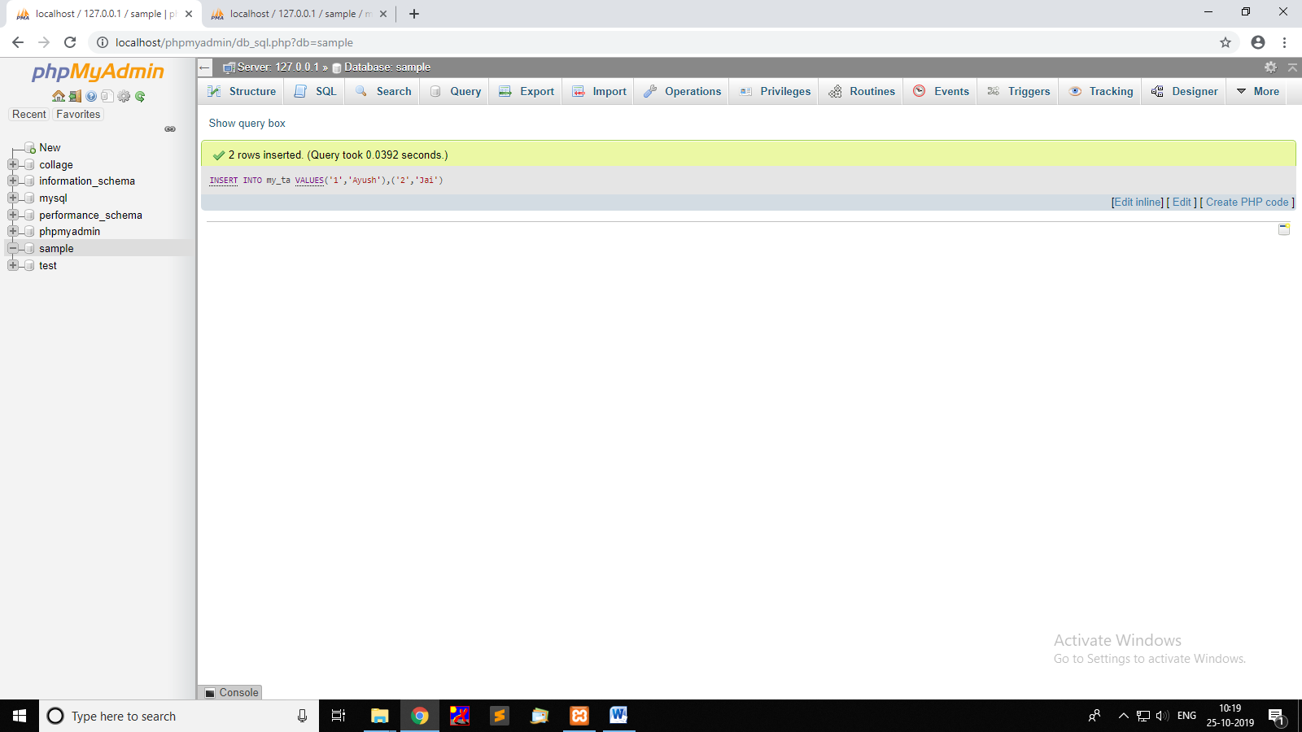
3. List the difference between Insert & Update  
   Insert will create new rows while  
   Update modifies the previous inserted rows.
4. List the datatypes used in MySQL  
   INT  
   VARCHAR  
   TEXT  
   DATE  
    NUMERIC  
    INT,FLOAT,DOUBLE,DECIMAL,REAL  
    DATE & TIME  
    DATE, TIME, DATETIME, TIMESTAMP, YEAR  
    STRING  
    CHAR, VARCHAR, TEXT
5. What is a Join & mention the different types of Joins  
   It is used to combine two or more tables   
     
   INNER JOINT : Returns records that have matching values in both  
    tables  
   LEFT JOINT : Returns all records from the left table, and the matched   
    records from the right table  
   RIGHT JOINT : Returns all records from the right table, and the   
    matched records from the left table  
   OUTER JOINT : Returns all records when there is a match in either  
    left or right table
6. What is the aggregate function & mention some functions along with the purpose  
   Pre-defined functions   
   Conversion Functions – Convert data with CAST and CONVERT  
   Logical Functions – execute one expression versus another depending on the outcome of a logical comparison.  
   Ex: IFF(),[>,<,==,<=,>=],ISNULL()

Math Functions – perform advanced calculations and round numbers.  
Ex: COUNT(),MAX(),MIN(),PI(),SUM(),AVG()

String Functions – change text values to all upper case, or remove the trailing spaces from values.  
Ex: UPPER(),LOWER()

Date Functions – add days or months to a date. Calculate the day of week from the date.  
Ex: DAY(),MONTH(),YEAR()

1. Create a database for employee management & create the tables accordingly  
   CREATE database DB_EMPLOYEE;  
   CREATE TABLE *TB_EMPLOYEE(id int PRIMARY KEY,name text,dob date);*CREATE TABLE *TB_EMPLOYEE_INFO(id int,dep text,salary int,FOREIN KEY int REFRENCES TB_EMPLOYEE(ID));*CREATE TABLE *TB_EMPLOYEE_DATA(id int,address text,addpin int,no int,FOREIN KEY int REFRENCES TB_EMPLOYEE(ID));*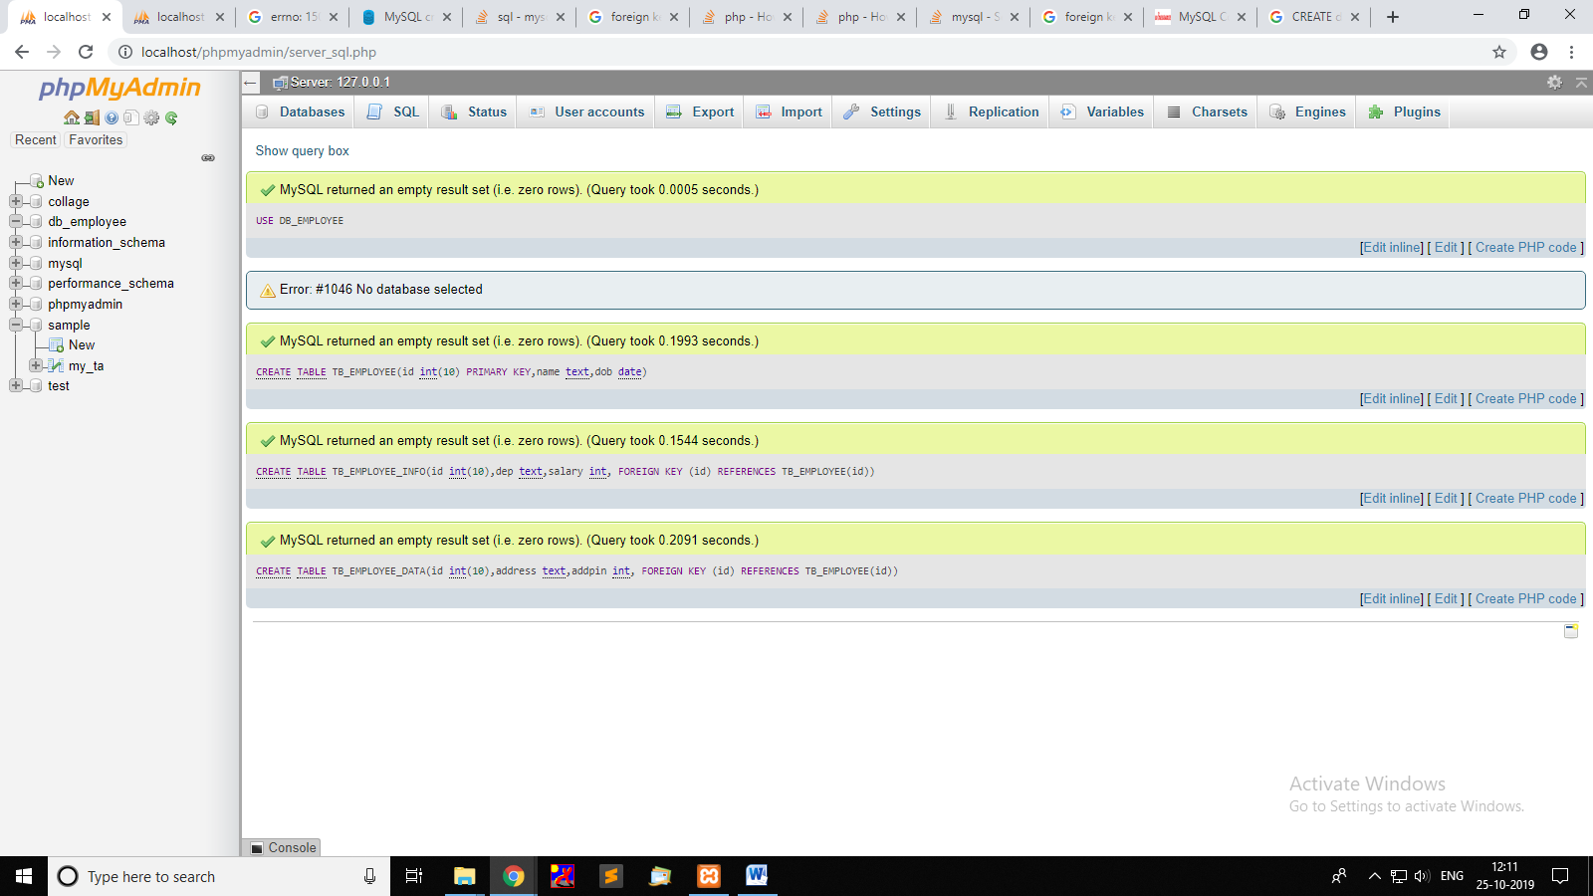

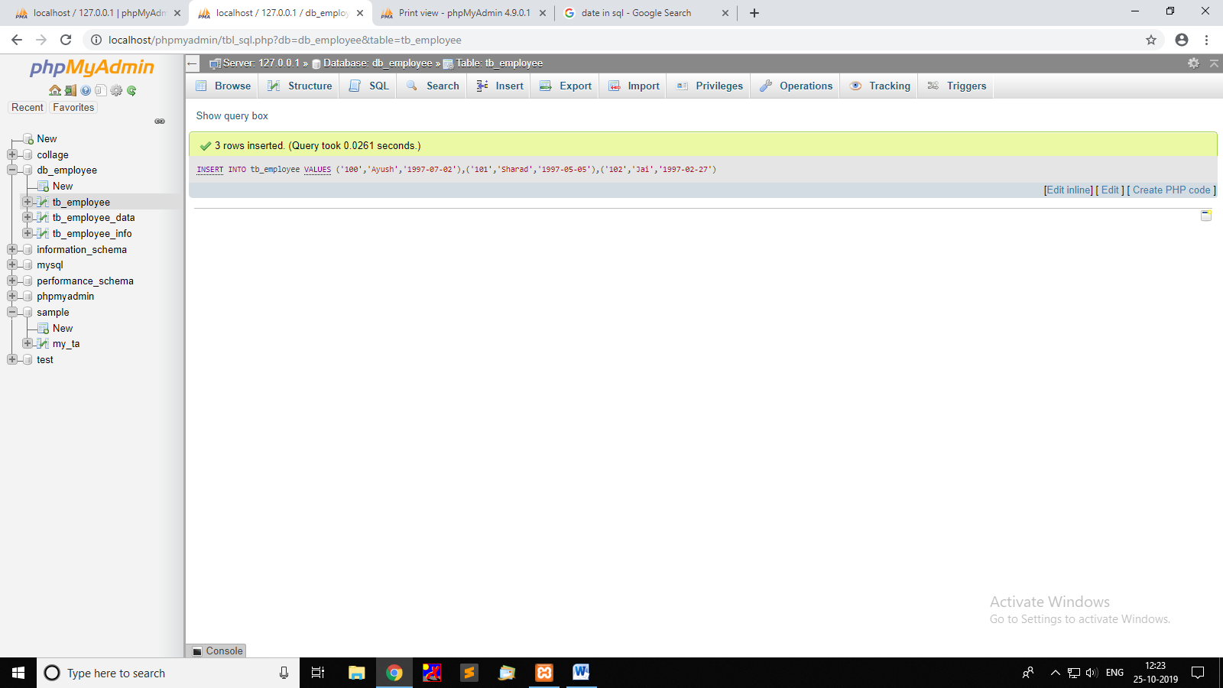

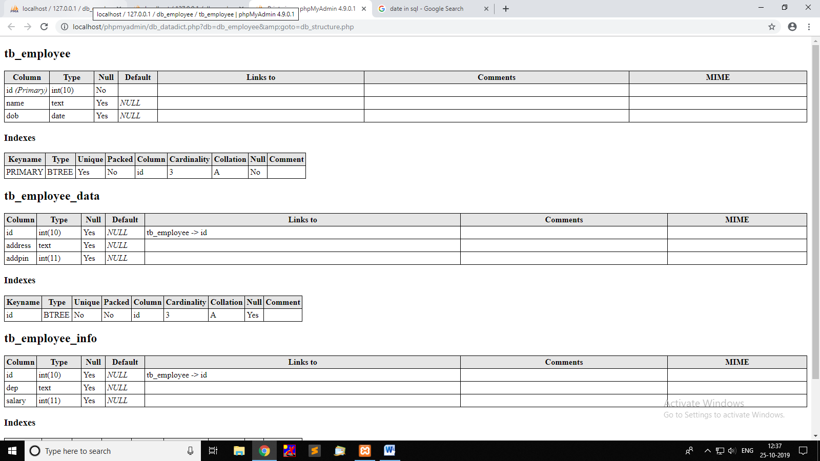

1. From the database created in Question 13, list the employees information in ascending order  
   Select * from TB_EMPLOYEE   
   ORDER BY name;  
   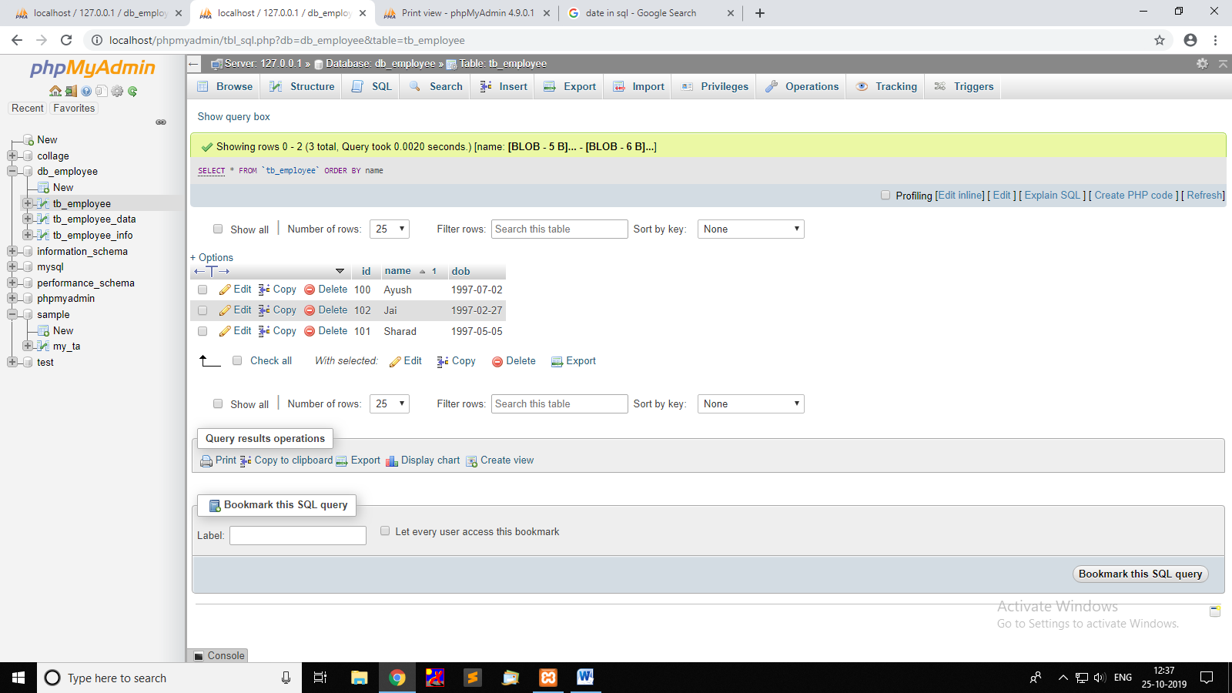
2. From the database created in Question 13, list the employees based on the salary in descending order  
   Select * from TB_EMPLOYEE_INFO, TB_EMPLOYEE WHERE(TB_EMPLOYEE_INFO.id = TB_EMPLOYEE.id) ORDER BY salary DESC;

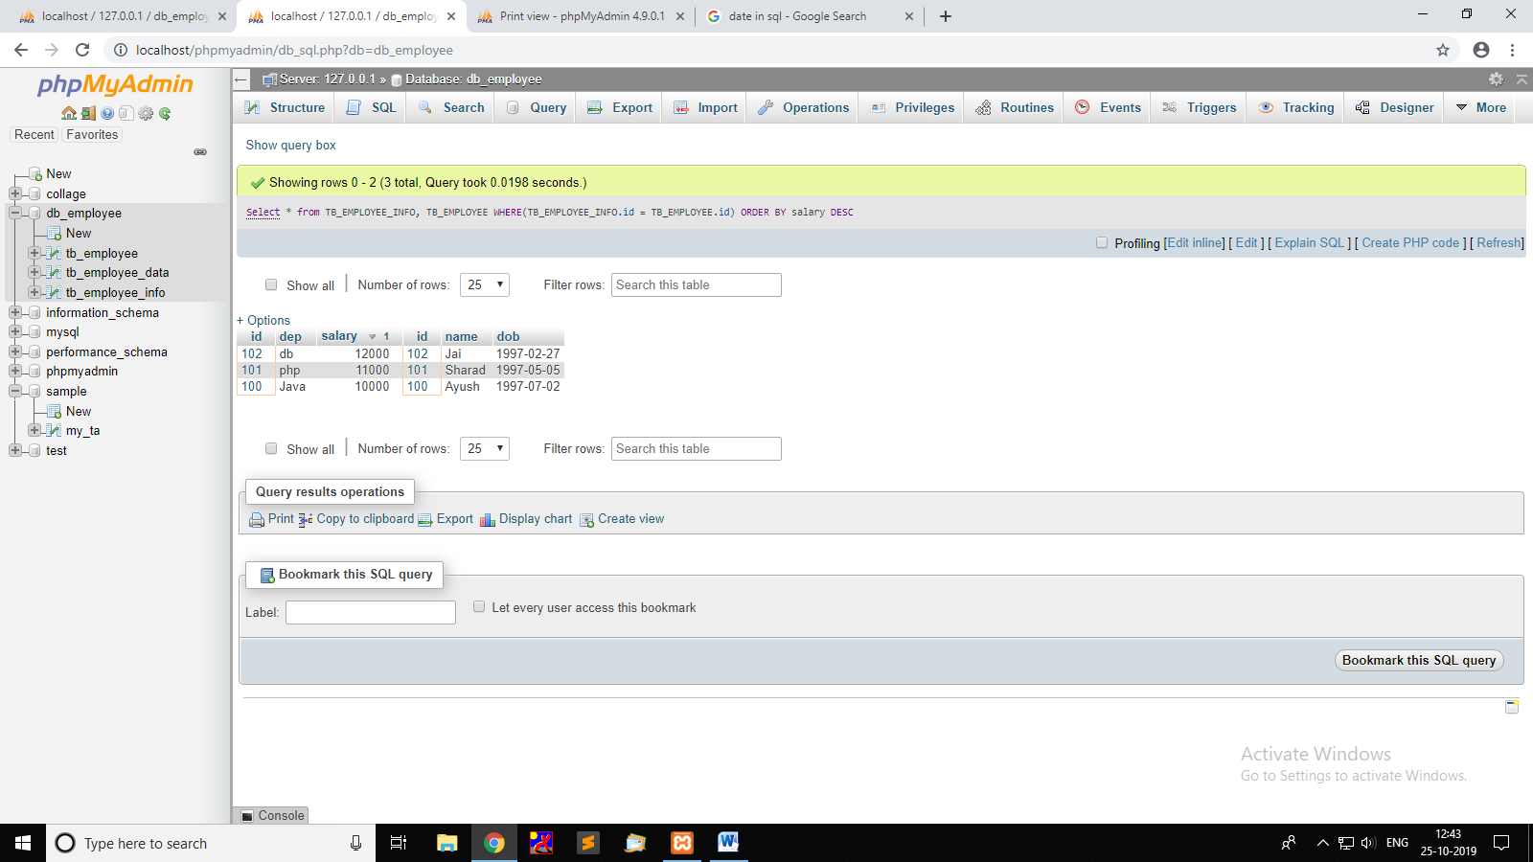

1. From the database created in Question 13, update the employee contact no based on the employee id  
   Creaation :   
   ALTER TABLE tb_employee_data ADD no INT(10) NOT NULL ;  
     
   UPDATE tb_employee_data SET no='777777777' WHERE id = '100';  
   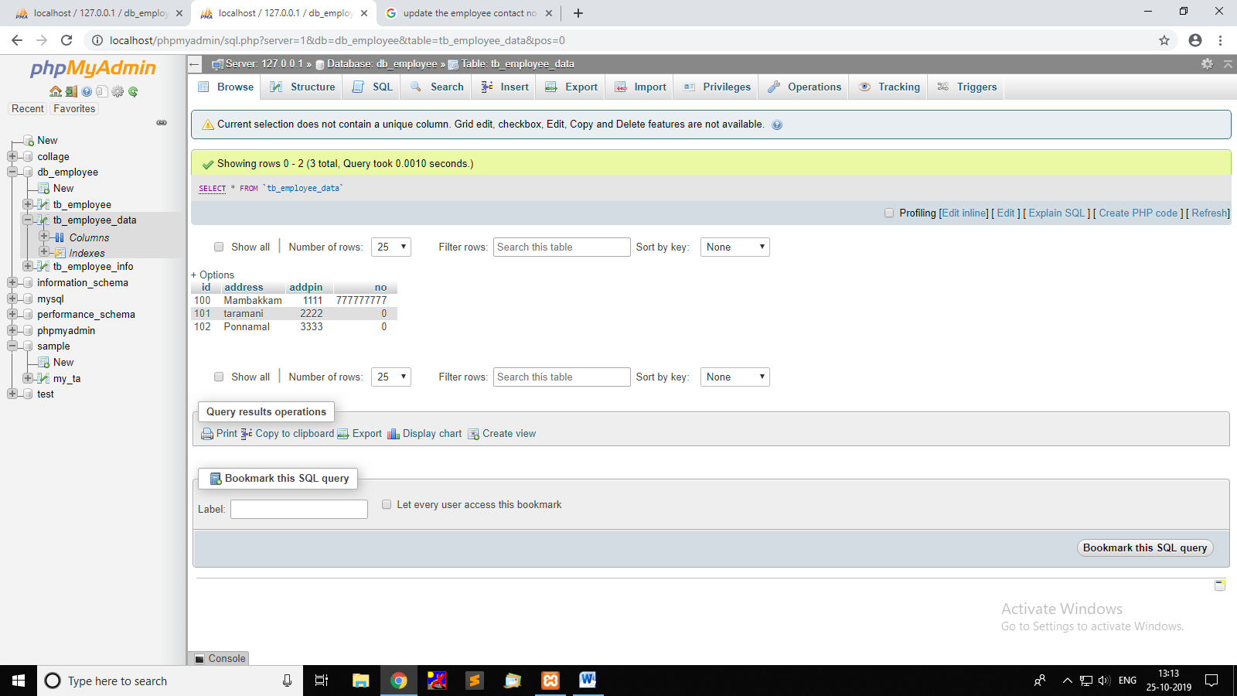
2. From the database created in Question 13, delete the employees who have the name starting with ‘D’. ( All the related information has to be deleted)  
   DELETE FROM TB_EMPLOYEE WHERE NAME LIKE '%D';  
     
   #ignore foreign key  
   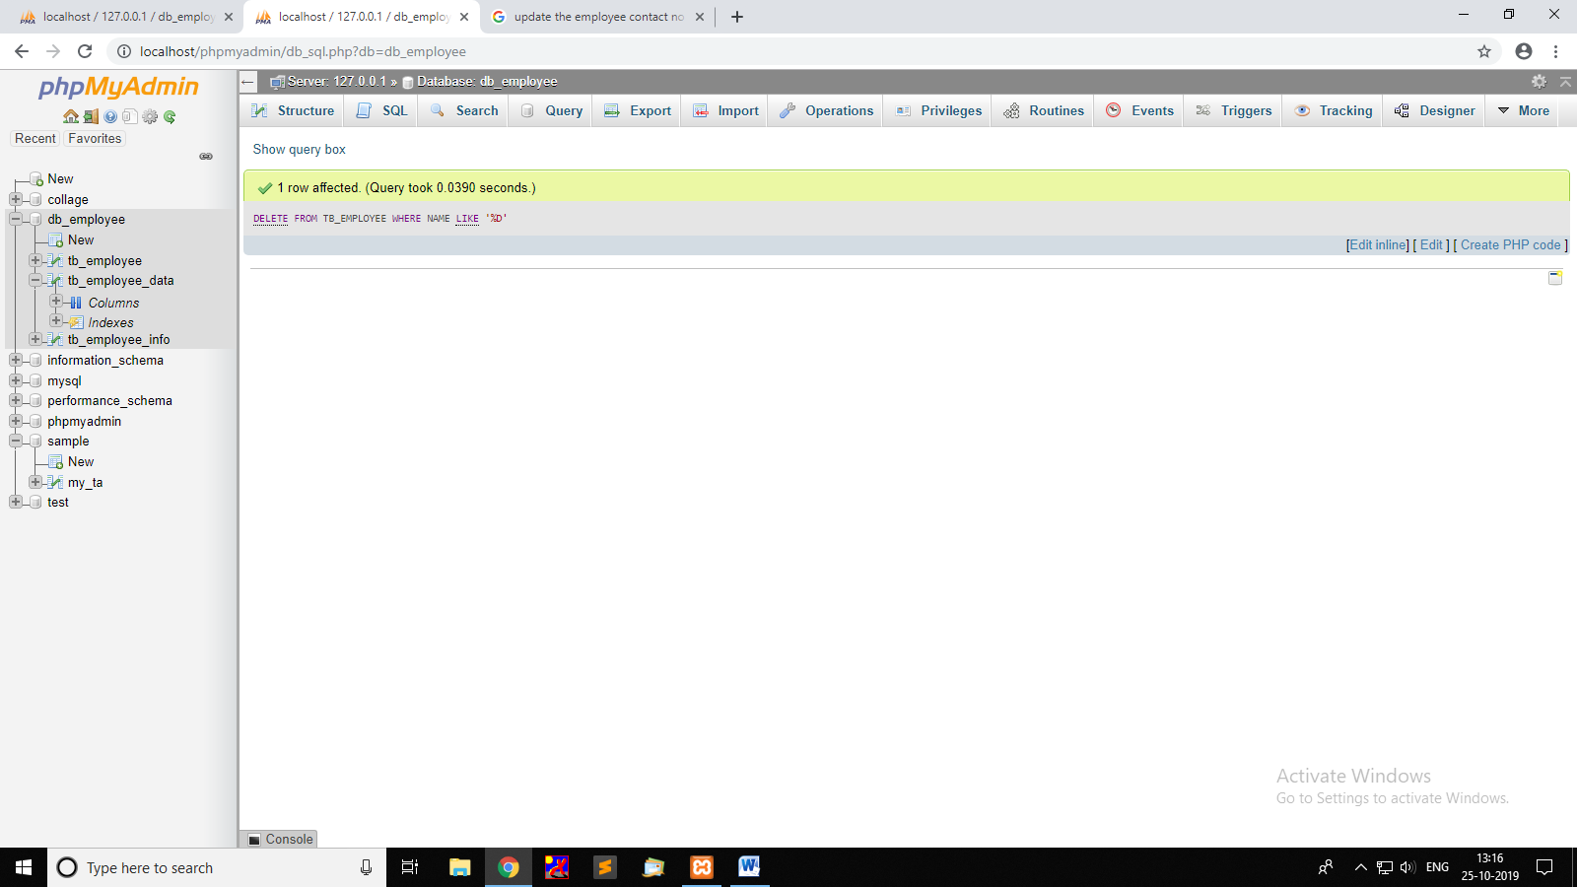
3. Create a country table with the below columns and insert some valid data.
   1. Primary key
   2. Country Name
   3. Country Code
   4. Date of creation
   5. Reference of the user created

CREATE TABLE country(id int(10),cname text,ccode int PRIMARY KEY,cdate date DEFAULT NOW(), FOREIGN KEY (id) REFERENCES tb_employee(id));  
  
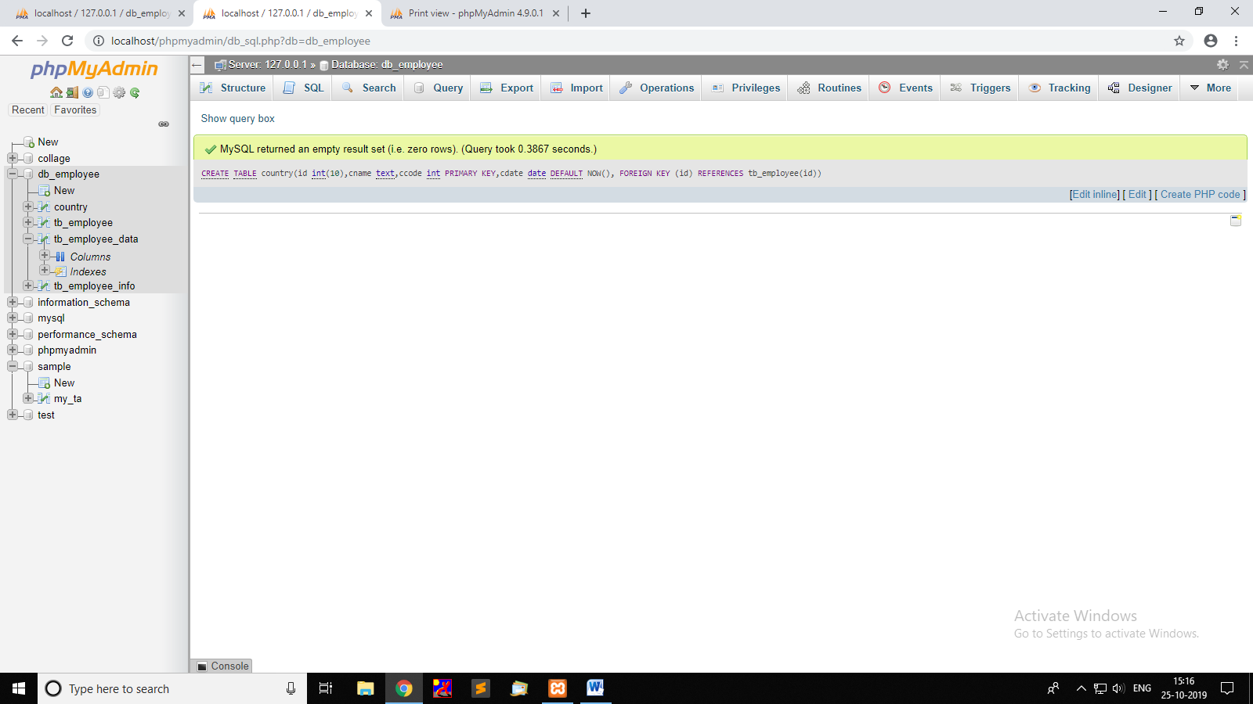

1. Write a simple function to list the country code & country name  
   SELECT country_code, country_name   
   CASE WHEN country_code = 'US' then country_name ='United States'  
   WHEN country_code = 'CA' then country_name ='Canada'  
   WHEN country_code = 'IN' then country_name ='India'  
   END, FROM COUNTRY;

1. Write a query to select the employee who received the second highest salary  
   concept sub query

SELECT tb_employee.id,tb_employee.name, MAX(tb_employee_info.salary) From tb_employee, tb_employee_info WHERE tb_employee_info.salary < ( SELECT Max(tb_employee_info.salary) FROM tb_employee_info) AND tb_employee.id=tb_employee_info.id ;

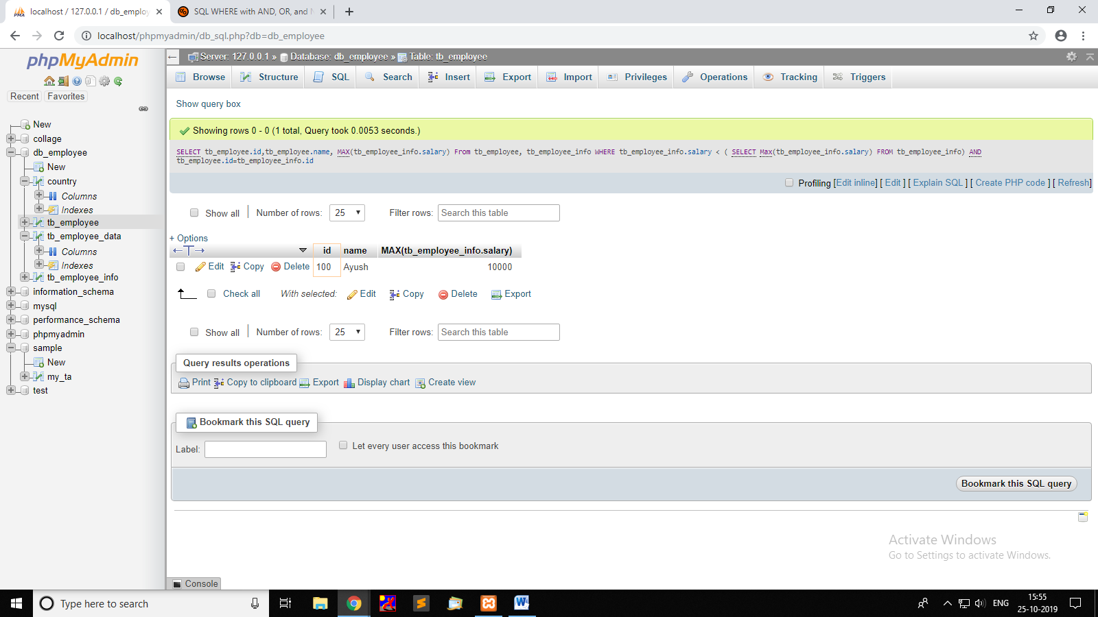

1. Create the tables for State, City and relate the same with Employee management  
     
   CREATE TABLE AREA(code number primarykey, state varchar(20), city varchar(20));  
     
   Select *TB_EMPLOYEE*.name, *AREA* .code, *AREA.STATE , AREA.CITY FROM AREA , TB_EMPLOYEE WHERE(TB_EMPLOYEE.code== AREA* .code);
2. List the employees Country wise, State wise & City wise  
   Select *TB_EMPLOYEE* .name, *TB_EMPLOYEE_INFO* .country, *TB_EMPLOYEE_INFO* .state, *TB_EMPLOYEE_INFO* .city from TB_EMPLOYEE , *TB_EMPLOYEE_INFO*;
3. What is a DB routine? Mention the purpose of using it.

It’s a kind of procedure that have logic implemented with only SQL statements, including SQL Procedural Language (SQL PL) statements. SQL routines are characterized by having their routine-body logic contained within the CREATE statement that is used to create them.

1. Write the syntax of Stored Procedure, Function & View  
   Procedure:  
   CREATE PROCEDURE procedure_name  
   AS  
   sql_statement  
   GO;

Function:  
CREATE FUNCTION function_name

[(i [IN | OUT | IN OUT] type [, ...])]

RETURN return_datatype

{IS | AS}

BEGIN

function_body

END [function_name];

View:

CREATE PROCEDURE n1 @City nvarchar(30), @PostalCode nvarchar(10)

AS

SELECT * FROM n1 WHERE City = @City AND PostalCode = @PostalCode

GO;

1. What is the difference between Stored Procedure & Function  
   The function must return a value but in Stored Procedure it is optional, a procedure can return zero or n values. Functions can have only input parameters for it whereas Procedures can have input or output parameters.
2. Create a stored procedure to perform the DML operations  
   CREATE PROCEDURE SelectAllEmployees  
   AS  
   SELECT * FROM Employees   
   GO;
3. Create a stored procedure to visualize a employee information  
   CREATE PROCEDURE SelectAllEmployees  
   AS  
   SELECT * FROM Employees  
   GO;